STOCK TAKING SHEETS / INS TUBE FLAP CHECKING TOOL GUIDE
- Open SAP and Navigate to Transaction:
  - Navigate to transaction code ZNBPSTK.
  - Enter your plant code and click Execute.
- Export to Spreadsheet:
  - Export only by Right-clicking anywhere in the data table and choose Export > Spreadsheet. When the format prompt appears, choose the Excel (in Office 2007 XLSX Format) option.
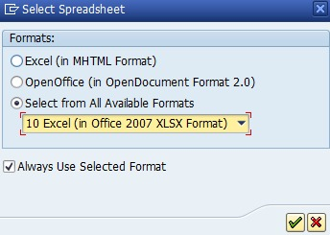
  - Save the file to your desired location. The spreadsheet will open automatically once saved.
- Create a New Sheet for Undelivered Stock:
  - In this newly opened spreadsheet, create a new worksheet tab named “UD” and place it immediately after Sheet1.
  - In SAP, use transaction ZDL to pull your undelivered stock data. In ZDL data, Sort Material code in ascending order.
  - Copy the below mentioned required data from the ZDL transaction and paste it into the “UD” sheet starting at cell A1 in this sequence.
    - Column A: Product code
    - Column B: Product description
    - Column C: Quantity
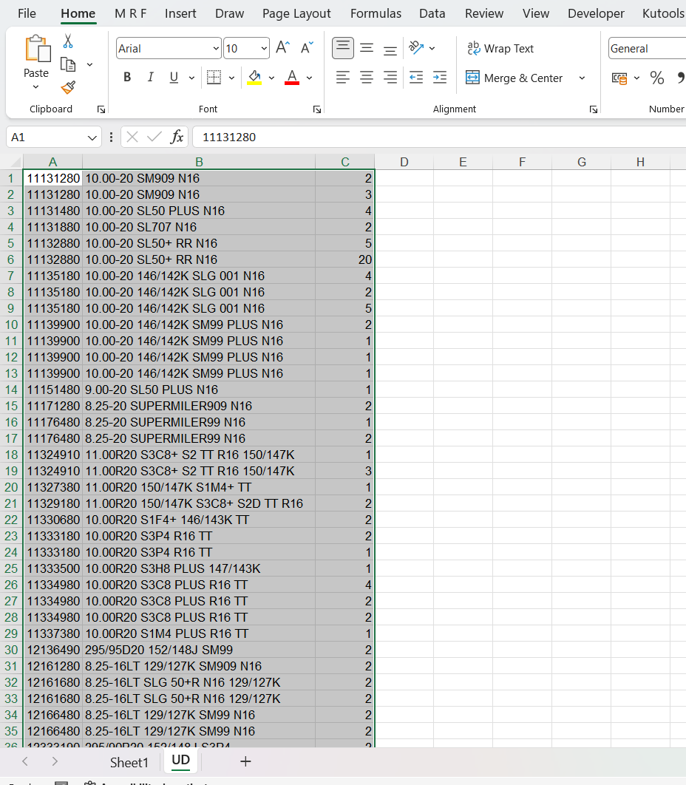

- Use the M R F Tab in Excel:
  - In the "M R F" tab next to the Home tab in Excel, click on the "Stock Taking Utility" icon.
  - 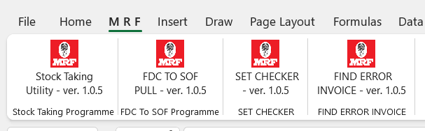
- Execute the Stock Taking Process:
  - The tool will execute the stock-taking programme. Wait a moment for the process to fully complete. Also note that the Stock sheets will auto remove Storage Locations “0400” & “0500” while considering for stock taking.
- Finish:
  - Once the process is complete, review the results as needed in auto-generated worksheet TTF2.

